“Anti-Skid Service Required” problem caused me headache when I bought 2009 Volvo XC90 at 2015. Sometime have problem, sometime not, sometimes have “brake failure stop safely” happened.

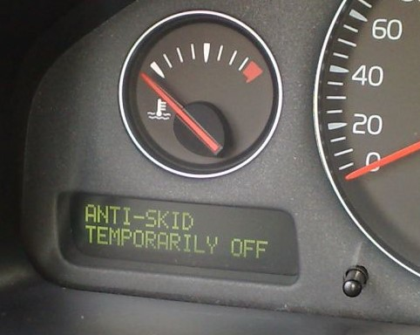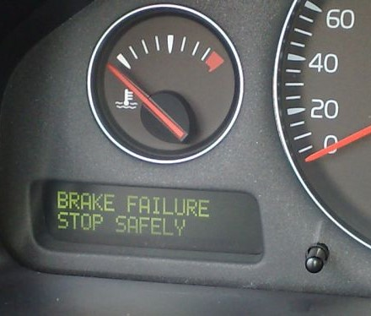

At 2016, I bought Volvo diagnostic tools and try to resolve this problem. Most of direction led me to check Steering angle Sensor, So, I opened Steering angle Sensor and cleaned Grating and Transmitter and receiver. Problem still same especially at winter time, it became worse.
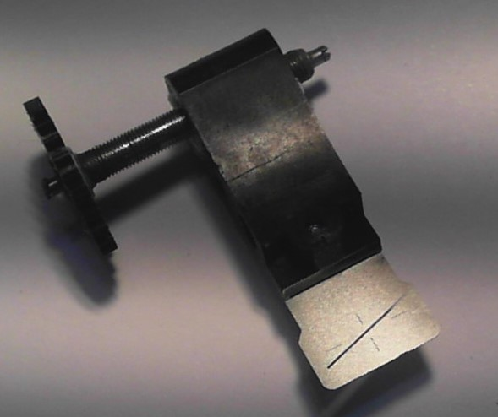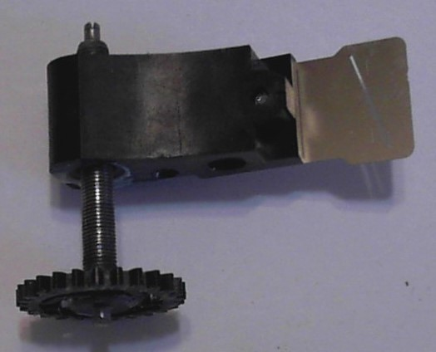
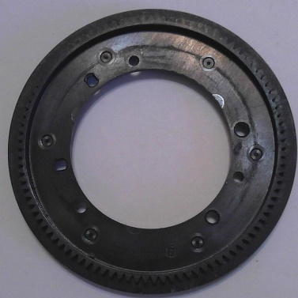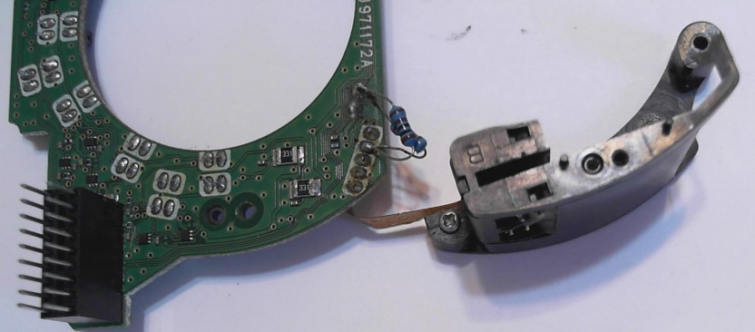

So, I doubted my Steering angle Sensor maybe have failure.
Later on, I had chance to get several Steering angle Sensors from used car, test them in my car, still have “Anti-Skid Service Required” problem sometimes. So, I thought it is not Steering angle Sensor problem.

Till to 2018, when I touched 36 pin connectors (54/3.1:1-36) wires, “Anti-Skid Service Required” happened. So, I knew problem happened in here. But there are too many wires need to solder, and also, it is tuff for further repair if need disconnect this connector.
On 2019 winter time, car have “brake failure stop safely” issue and can’t change gear during long distance driving. I have to go to Volvo dealer, they just cleaned error. So, money spent while problem still kept.

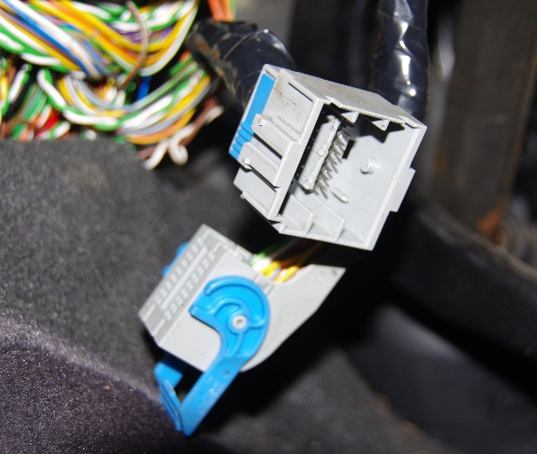
At May2021, I thought I need to sale this car and I don’t want kick this ball to buyer. So, I decided to fix it. I searched wire diagram of XC90, found there are just 7 wires need to solder them together. There are terminal 5,6,7,8, 11,12,18. I decided to duplicate them since there are sufficient blank terminals.
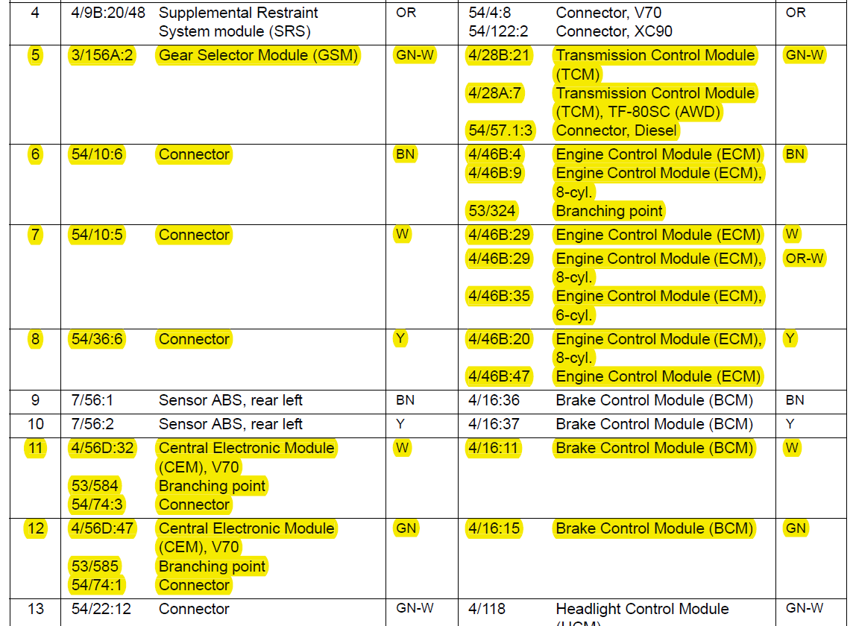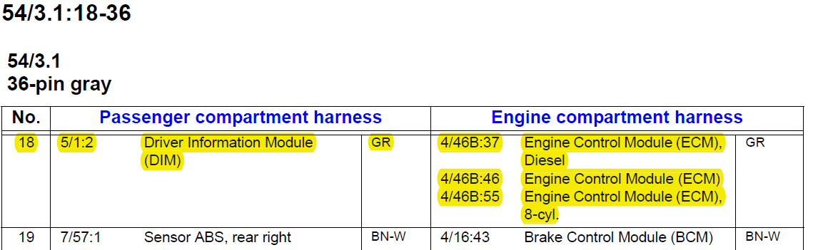

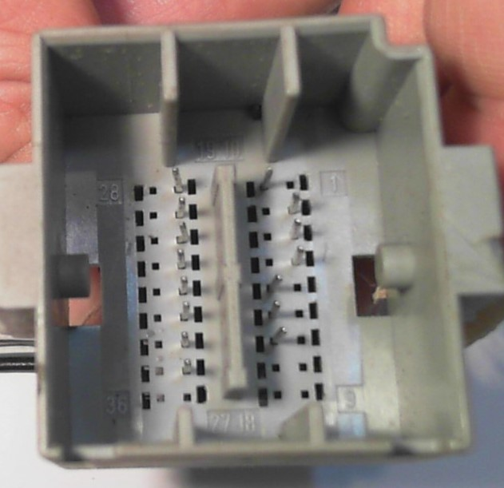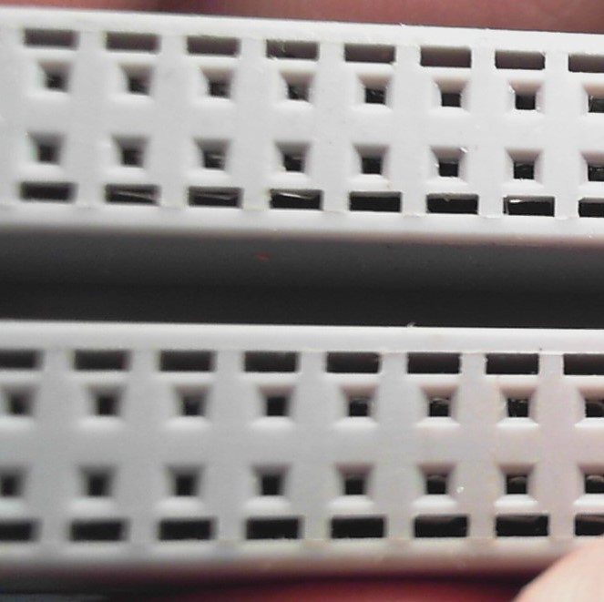

So, I got some male and female connectors, made a sharp insert tool (using Wago screw driver), duplicated and soldered terminal 5,6,7,8, 11,12,18, checked each male and female contact pins force, felt tight or not. If feel not tight, means has poor contact, need to solder another terminal. After everything are ok, I tested, there were no “Anti-Skid Service Required” and “brake failure stop safely”.
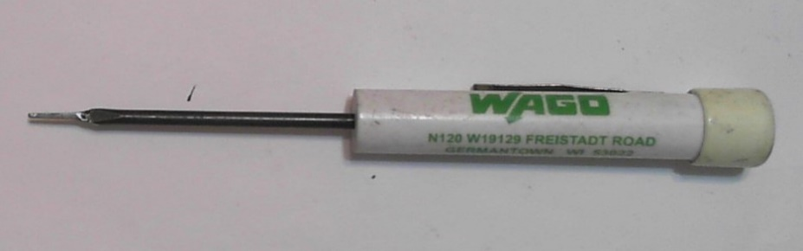
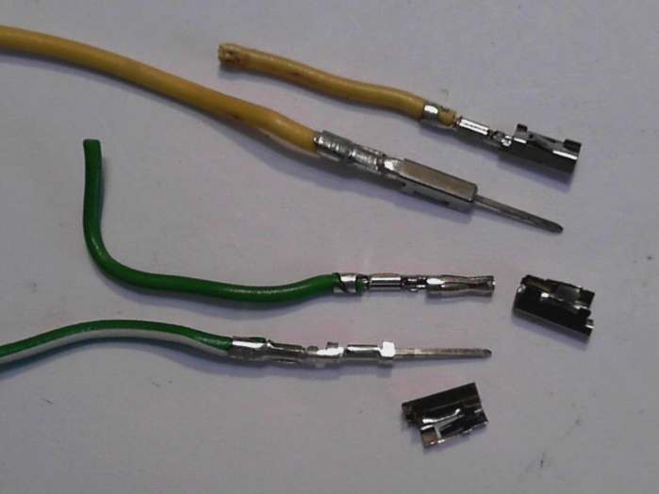
Till right now, there are no problem any more. So, Problem is this connector! And this connector come from my previous company!
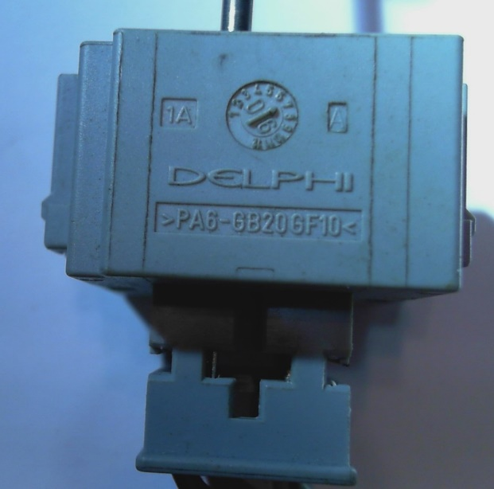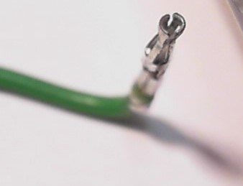
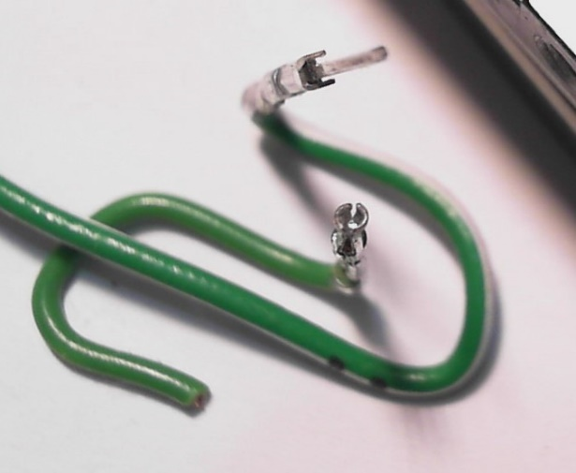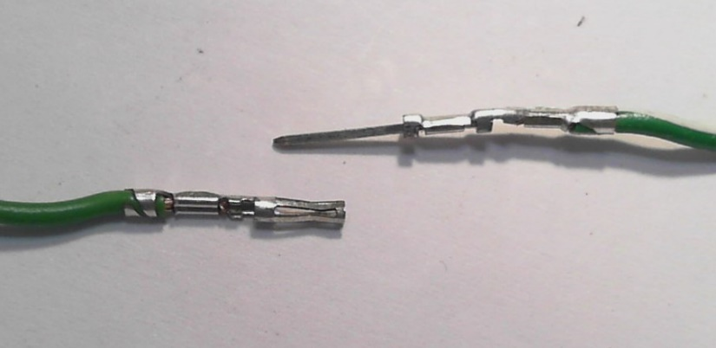

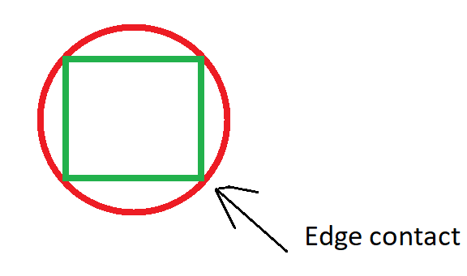
Since I worked at DELPHI technical center, served as Mechanical Engineer before. For this connector issue, I suppose it should be never happened if Mechanical Engineer and EE consider failures in advance use DFMEA whatever DELPHI or Volvo Engineer. So, I have following suggestions.
1, If there are some wires are very critical and have high risk cause failure that customer dissatisfied such as brake failure, need consider duplicate them.
2, Male terminal section is square shape and Female terminal is circle. If connect them together, there will be edge contact or point contact. This kind of contact can’t be used for high current and has reliability issues since edge will be oxidized. So, it is better to consider how to make round male terminal to form surface contact. I suppose it is not difficult for manufacturing Engineer.
3, I have no way to determine what kind of material and coating used for Female terminal, Maybe it is SUS with Sn coating. I suppose it is better use Beryllium copper with golden coating since it has good Elastic deformation and good conductivity.

Notes:
XC90 wire diagram refer to http://vidaresources.volvocars.biz/ewd/Eng/3998202/images/3998202.pdf

